A PROJECT REPORT
ON
"MINDBLOOM"
SUBMITTED IN PARTIAL FULFILLMENT OF THE REQUIREMENT FOR THE DEGREE OF

BACHELOR OF TECHNOLOGY
IN
COMPUTER SCIENCE & ENGINEERING

Submitted By

Jha Aditi Ashokkumar (220220411)
Nandini Bharti (220220199)
Purva Nilakh (220220160)

Under the Guidance of
Mr. S. Vijayakumar


DEPARTMENT OF COMPUTER SCIENCE AND INFORMATION TECHNOLOGY
CHHATRAPATI SHIVAJI MAHARAJ UNIVERSITY
PANVEL, NAVI MUMBAI

[2025-26]
DEPARTMENT OF COMPUTER SCIENCE AND INFORMATION TECHNOLOGY
CHHATRAPATI SHIVAJI MAHARAJ UNIVERSITY
PANVEL, NAVI MUMBAI

[2025-26]



Certificate
This is to certify that the project entitled MindBloom is a bonafide work carried out by Jha Aditi Ashokkumar, Nandini Bharti, and Purva Nilakh, submitted to the Chhatrapati Shivaji University, Panvel, Navi Mumbai, in partial fulfillment of the requirements for the award of the degree of Bachelor of Technology in CSE.
______________
Mr. S. Vijayakumar
(Project Coordinator)

______________
Prof (Dr) Vikas Kumar (Head of the Department)

Project Report Approval for B. Tech.

This project report entitled MindBloom was submitted by
Jha Aditi Ashokkumar, Nandini Bharti, Purva Nilakh has been approved for the award of the degree of Bachelor of Technology in Computer Science Engineering.

Examiners

1.

2.

Date:

Place:

Declaration

We declare that this written submission represents our ideas in our own words, and wherever others’ ideas or words have been included, we have adequately cited and referenced the original sources. We also declare that we have adhered to all principles of academic honesty and integrity and have not misrepresented, fabricated, or falsified any idea/data/fact or source in this submission. We understand that any violation of the above will be cause for disciplinary action by the university and may also invite penal action from the sources that have not been properly cited or from whom proper permission has not been obtained where required.

Signature

Jha Aditi Ashokkumar
Nandini Bharti
Purva Nilakh

Date:

Place:

Abstract

MindBloom is a digital behavioral-tracking and psychological well-being monitoring application designed for parents and teachers. Early identification of emotional or behavioral challenges in children is often missed due to a lack of structured tools, inconsistent communication, and absence of real-time monitoring. MindBloom addresses this gap by integrating behavior tracking, progress analysis, alert systems, and collaborative communication tools. The system allows parents and teachers to record observations, identify early warning signs, generate behavior analytics, and access AI-assisted suggestions for improving the child’s mental and emotional development.

Keywords: Child Psychology, Behavioral Tracking, Mental Well-Being, Parent-Teacher Collaboration, AI Guidance System, Early Warning Detection.

i

Abbreviations

ML | Machine Learning
GUI | Graphical User Interface
UI | User Interface
CNN | Convolutional Neural Network
DL | Deep Learning

ii

List of Figures

Figure Number | Figure Name | Page No.
5.1 | Use Case diagram | 20
5.2 | Activity diagram | 21
5.3 | Class diagram | 22
5.4 | Sequence diagram | 23
6.3 | DFD Flow diagram | 25
6.4 | Flow Chart | 26

iii

List of Table

Table No. | Table Name | Page No.
Table 4.2 | Gantt Chart | 15

iv

Table of Contents

Content | Page No.
Abstract | i
Abbreviations | ii
List of figures | iii
List of tables | iv
1. Introduction | 1
1.1 Background | 2
1.2 Relevance | 2
1.3 Organization of the Report
2. Literature Review | 8
2.1 Related work | 4
2.2 Basic Terminologies
2.3 Existing System | 5
2.4 Problem Statement | 5
3. System Requirement Specification | 12
3.1 Software Requirement | 7
3.2 Hardware Requirement
4. Plan of Project | 8
4.1 Methodology | 9
4.2 Project Plan (Gantt Chart) | 10
4.3 Proposed System | 11
5. Project Analysis | 12
5.1 Use Case Diagram | 13
5.2 Use case Analysis | 14
5.3 Class Diagram | 15
5.4 Activity Diagram | 15
5.5 Sequence Diagram | 15
6. Project Design | 15
6.1 Data Flow Diagram | 20
6.2 Flow Chart | 22
7. Implementation | 26
7.1 System Architecture | 28
7.2 Sample code | 29
8. Result Analysis | 30
9. Conclusion and Future scope | 31
References | 32
Acknowledgement | 34
Appendix I : List of Publication | 35
Appendix II : Published Paper | 36
Appendix III : Plagiarism report of paper | 29

Chapter 1
Introduction

1

Introduction

Childhood is a critical phase in human development, where cognitive, emotional, social, and behavioral foundations are established. During this stage, children exhibit various behavioral patterns that reflect their internal emotional state and developmental progress. Early identification of deviations in these patterns is essential, as it allows timely intervention and support, significantly improving long-term developmental outcomes.
In real-world scenarios, behavioral observations are primarily carried out by parents at home and teachers in educational environments. However, these observations are often unstructured, subjective, and inconsistent, leading to gaps in understanding the child’s overall psychological well-being. The absence of a centralized system results in fragmented information, delayed detection of potential issues such as anxiety, attention disorders, or developmental delays, and ineffective communication between stakeholders.
Traditional methods, such as parent-teacher meetings and manual record-keeping, lack continuity, scalability, and analytical capabilities. These approaches rely heavily on memory and personal interpretation, which can introduce bias and reduce accuracy. Furthermore, there is minimal use of technology to analyze behavioral data or identify patterns over time.
To address these challenges, the MindBloom system is proposed as a digital behavioral tracking and psychological monitoring platform. MindBloom aims to provide a structured and systematic approach to recording, storing, and analyzing children’s behavioral data. It enables parents and teachers to collaboratively monitor a child’s development through a unified interface, ensuring consistency and transparency in observations.

2
The system leverages modern web technologies along with data-driven analytics and AI-assisted insights to detect early warning signs of emotional or behavioral issues. By transforming raw observational data into meaningful insights, MindBloom supports proactive decision-making and encourages early intervention strategies.
In addition to behavioral tracking, the system focuses on minimizing screen exposure for children by adopting a parent-first interaction model, where adults log observations rather than children directly engaging with the system. This approach aligns with pediatric recommendations and ensures ethical and responsible use of technology.

Overall, MindBloom represents an innovative integration of psychology and technology, offering a scalable, efficient, and user-friendly solution for improving child development monitoring and strengthening collaboration between parents and educators.

1.1 Background

The early years of a child’s life are crucial for brain development and behavioral formation. During this period, children acquire essential skills related to communication, emotional regulation, and social interaction. However, subtle behavioral changes often go unnoticed due to lack of awareness, inconsistent monitoring, or absence of structured tools.
Research in child psychology emphasizes that early detection of developmental or emotional challenges—such as autism spectrum disorders, attention deficit disorders, or social anxiety—can significantly improve outcomes through timely intervention. Despite this, many existing systems fail to provide real-time monitoring or continuous tracking of behavioral patterns.
3

MindBloom is developed to bridge this gap by introducing a digital platform that systematically records behavioral observations and enables long-term analysis. By integrating inputs from both parents and teachers, the system provides a holistic view of the child’s development.

1.2 Relevance

In the modern educational and social environment, the psychological well-being of children has become a critical concern. With increasing academic pressure, changing family dynamics, and growing exposure to digital environments, children are more vulnerable to emotional, behavioral, and developmental challenges than ever before. Despite this, the tools and systems available for monitoring and supporting child development remain largely inadequate, unstructured, and reactive rather than proactive.

The relevance of the MindBloom system lies in its ability to address these challenges through a technology-driven, structured, and data-oriented approach to behavioral monitoring.

One of the key aspects that highlights the importance of this project is the need for early detection of psychological and developmental issues. Conditions such as anxiety disorders, attention deficit hyperactivity disorder (ADHD), autism spectrum disorders, and social withdrawal often begin with subtle behavioral changes. Without a proper monitoring system, these early signs are frequently overlooked, leading to delayed diagnosis and intervention. MindBloom provides a mechanism to continuously record and analyze behavioral data, enabling early identification of such issues.

4
Another important factor is the lack of effective communication between parents and teachers. Both stakeholders observe the child in different environments, but their observations are rarely integrated in a meaningful way. This results in fragmented understanding and inconsistent decision-making. MindBloom acts as a collaborative platform, ensuring that both parents and teachers have access to shared, real-time information, thereby improving coordination and consistency in monitoring the child’s development.
The project is also highly relevant in the context of digital transformation in education and healthcare. While many systems focus on academic performance or physical health, there is a noticeable gap in tools dedicated to psychological and behavioral tracking. MindBloom fills this gap by combining behavioral science with modern technologies such as web applications, cloud databases, and AI-based analytics.
Furthermore, the system promotes a data-driven approach to decision-making. Traditional methods rely heavily on subjective judgment, which may lead to bias or inaccuracies. In contrast, MindBloom collects structured data over time, identifies patterns, and generates analytical insights. This allows caregivers to make informed decisions based on evidence rather than assumptions.
Another significant aspect of the project’s relevance is its alignment with ethical and pediatric guidelines, particularly regarding screen time. Unlike many child-focused applications that increase direct screen exposure, MindBloom follows a parent-first interaction model, where adults input observations instead of children interacting with the system. This ensures responsible use of technology while still benefiting from its capabilities.
Additionally, the system is scalable and adaptable, making it suitable for a wide range of environments, including schools, households, and potentially clinical settings in the future. Its modular design allows for integration with advanced technologies such as wearable devices, emotion recognition systems, and predictive analytics, further increasing its long-term relevance.
5
In summary, the MindBloom project is highly relevant as it:
- Addresses the growing need for early psychological intervention
- Bridges the communication gap between parents and teachers
- Introduces a structured and analytical approach to behavioral monitoring
- Supports data-driven and evidence-based decision-making
- Aligns with modern technological advancements and ethical practices

Thus, MindBloom represents a timely and impactful solution that contributes significantly to improving child development monitoring and overall psychological well-being.

6

1.3 Organization of the Report

The report is organized into nine chapters that detail the development lifecycle of MindBloom:
- Chapter 1: Introduction – Provides the background, relevance, and an overview of the child psychological monitoring system.
- Chapter 2: Literature Review – Discusses foundational psychological theories, existing systems, and the specific problem statement being addressed.
- Chapter 3: System Requirement Specification – Outlines the software and hardware requirements necessary for the project.
- Chapter 4: Plan of Project – Details the methodology, the Gantt chart for the project timeline, and the proposed system architecture.
- Chapter 5: Project Analysis – Presents the technical modeling of the system through Use Case, Class, Activity, and Sequence diagrams.
- Chapter 6: Project Design – Focuses on the logical design through Data Flow Diagrams and detailed Flow Charts.
- Chapter 7: Implementation – Describes the final system architecture and provides samples of the application code.
- Chapter 8: Result Analysis – Evaluates performance metrics, including load times and the accuracy of behavioral insights.
- Chapter 9: Conclusion and Future Scope – Summarizes the project findings and suggests future enhancements like wearable integration and predictive analytics.

7

Chapter 2
Literature Review

8

Literature Review

2.1 Related Work

- Piaget’s Theory of Cognitive Development – Stages of child reasoning and learning.

- Vygotsky’s Social Development Theory – Role of interaction in learning and behavior.

- Erikson’s Psychosocial Theory – Childhood stages of trust, autonomy, initiative, and competence.

- WHO Reports (2022) – Urge early detection and collaborative support for child mental health.

2.2 Basic Terminologies

- Behavioral Tracking: The systematic process of observing, recording, and analyzing specific actions or emotional responses in a child over a set period to identify patterns.

- Early Detection/Intervention: The identification of developmental or psychological challenges during the initial stages of childhood, which is scientifically proven to improve long-term outcomes.

- Psychological Indicators: Observable signs, such as social withdrawal, frequent emotional outbursts, or changes in communication, that serve as markers for a child's mental well-being.

- Parent-Teacher Collaboration: A structured communication framework where both primary caregivers and educators share behavioral data to maintain a consistent record of a child's development.

9
- AI Guidance System: The use of machine learning algorithms to analyze logged behavioral data and provide actionable suggestions or alerts for caregivers.

- Developmental Delays: A situation where a child does not reach specific milestones (social, emotional, or cognitive) at the expected age.

- Supabase (Backend-as-a-Service): The database platform used in this project to handle real-time data storage and management for user logs and child profiles.

2.3 Existing System

Traditional systems rely on verbal communication between teachers and parents, manual observation notes, infrequent meetings, and lack structured assessment tools.
Disadvantages :
- Communication gaps between parents and teachers
- No centralized behavioral data storage
- Delayed identification of emotional issues
- Subjective interpretation of behavior
- Lack of analytics or pattern detection
- Inefficient tracking of long-term progress

2.4 Problem Statement

In the current system, children’s psychological development is not tracked systematically. The major challenges include:
- Delayed Detection: Behavioral disorders and learning difficulties are often identified too late.
- Limited Awareness: Parents and teachers may not recognize early signs of stress, anxiety, or ADHD.
- Communication Gaps: Lack of structured parent-teacher collaboration in tracking behavioral concerns.
- Fragmented Tools: Existing apps focus either on education or basic health but not psychology + collaboration + AI analysis together.
10

Compounding the issue, most digital tools are screen-based and child-facing, contradicting pediatric advice to minimize device exposure in early years. What’s urgently needed is a parent-first digital solution that enables early detection through offline, real-world activities, fosters structured collaboration between caregivers, and leverages AI to support holistic child development—without increasing screen time for children.

11

Chapter 3
System Requirement Specification

12

System Requirement Specification

3.1 Software Requirement:

      - Front End: HTML, JavaScript, CSS, React.js
      - Back End: Node.js with Express
      - Database: Supabase
      - Visual Studio: 1.117

3.2 Hardware Requirement:

      - Desktop/Laptop Processor: Intel i5 Core processor & Above

      - Desktop/Laptop RAM: 4GB & Above

      - Hard Disk: 1TB & Above

      - Monitor: Laptop/Desktop

13

Chapter 4 Plan of project

14

Plan of Project

  - Methodology

4.2 Project Plan (Gantt chart)

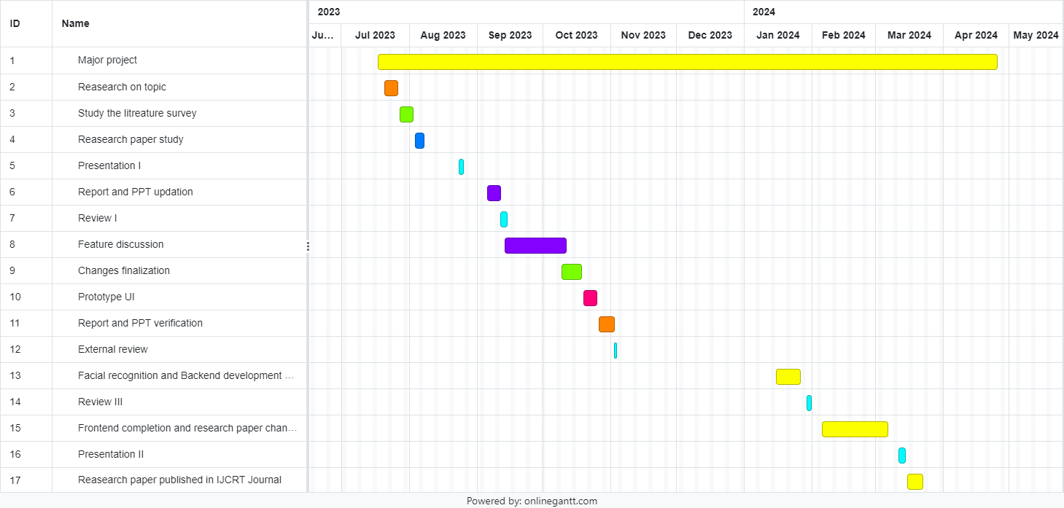

Figure 4.2: Gantt chart

15

4.3 Proposed System
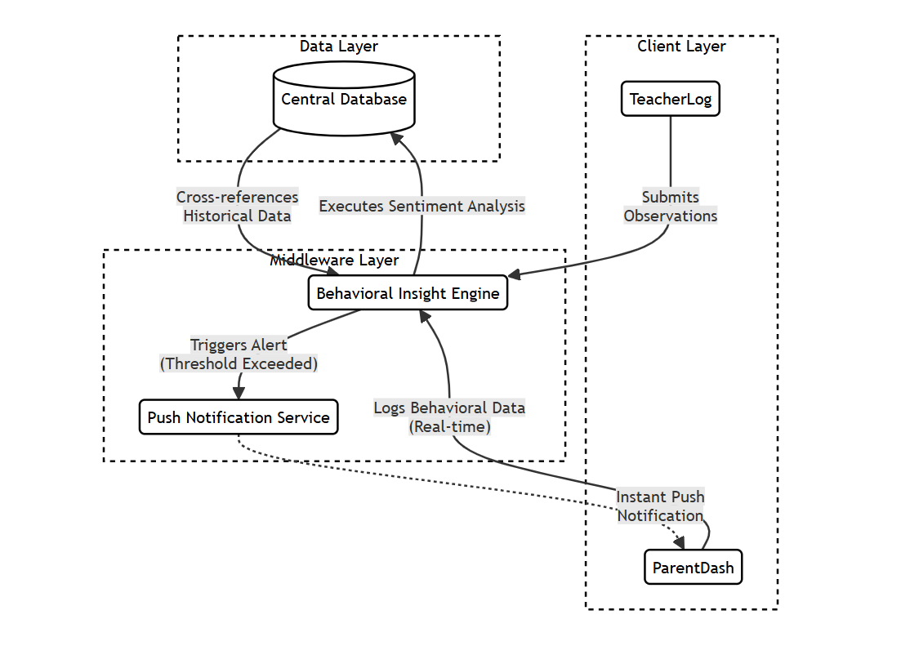
Figure 4.3: Proposed System architecture

16

Chapter 5
Project Analysis

17

Project Analysis

5.1 Use case Diagram:

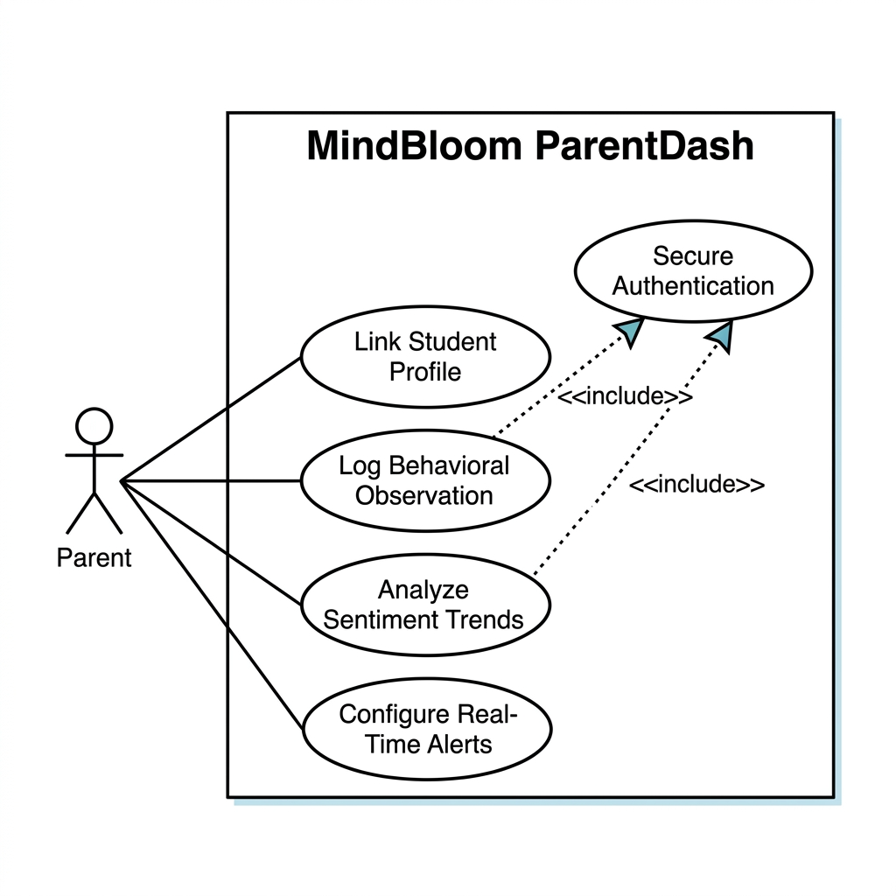

Figure 5.1: Use case diagram

18
5.2 Use Case Analysis

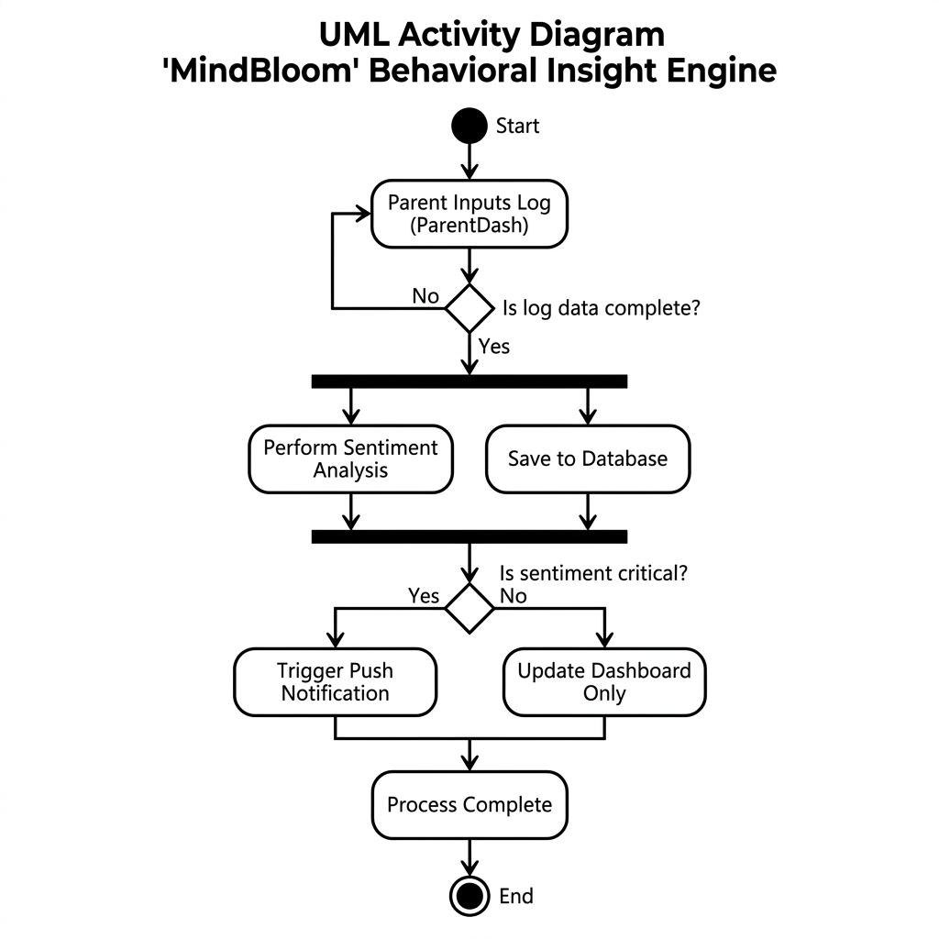

Figure 5.2: Activity Diagram

19

5.3 Class Diagram:

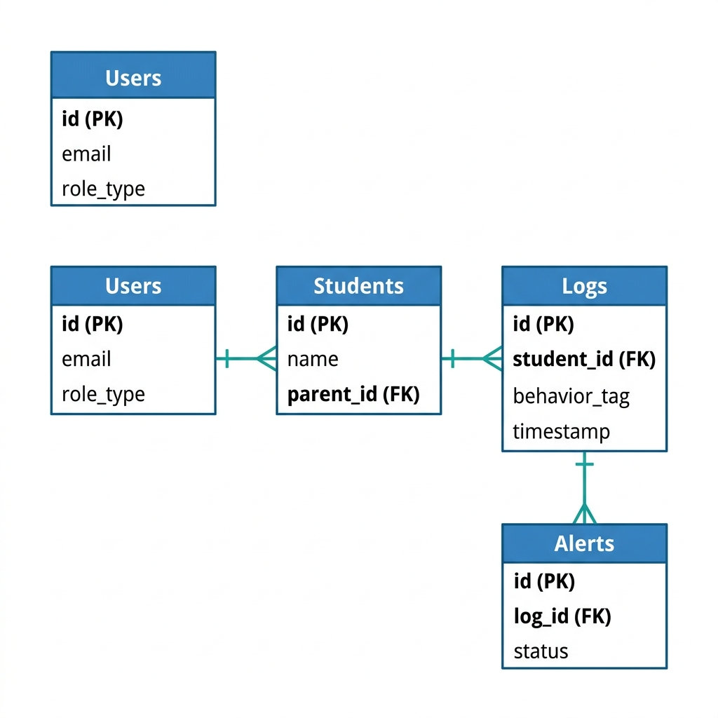

Figure 5.3: Class Diagram

20

5.4 Sequence Diagram:

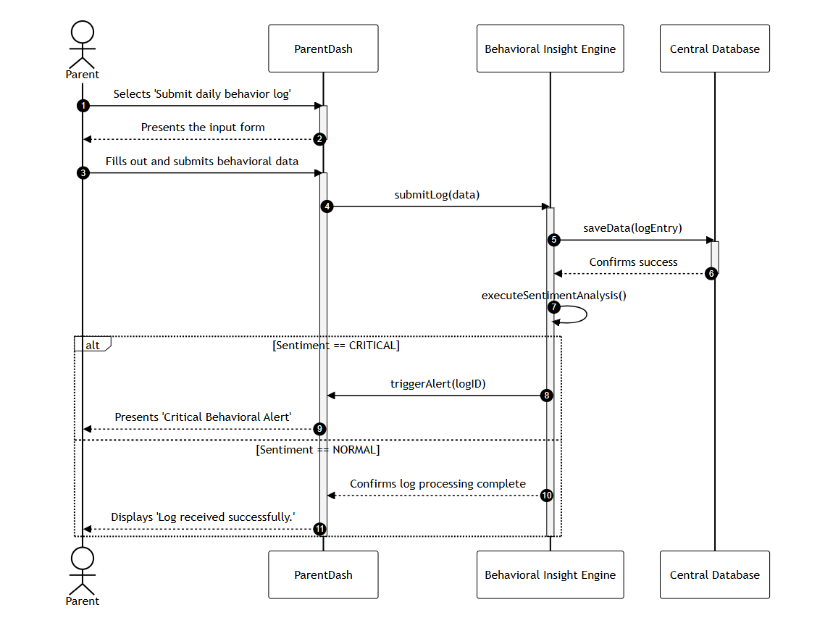

Figure 5.6: Sequence Diagram

21

Chapter 6
Project Design

22

6.1 Data Flow Diagram:

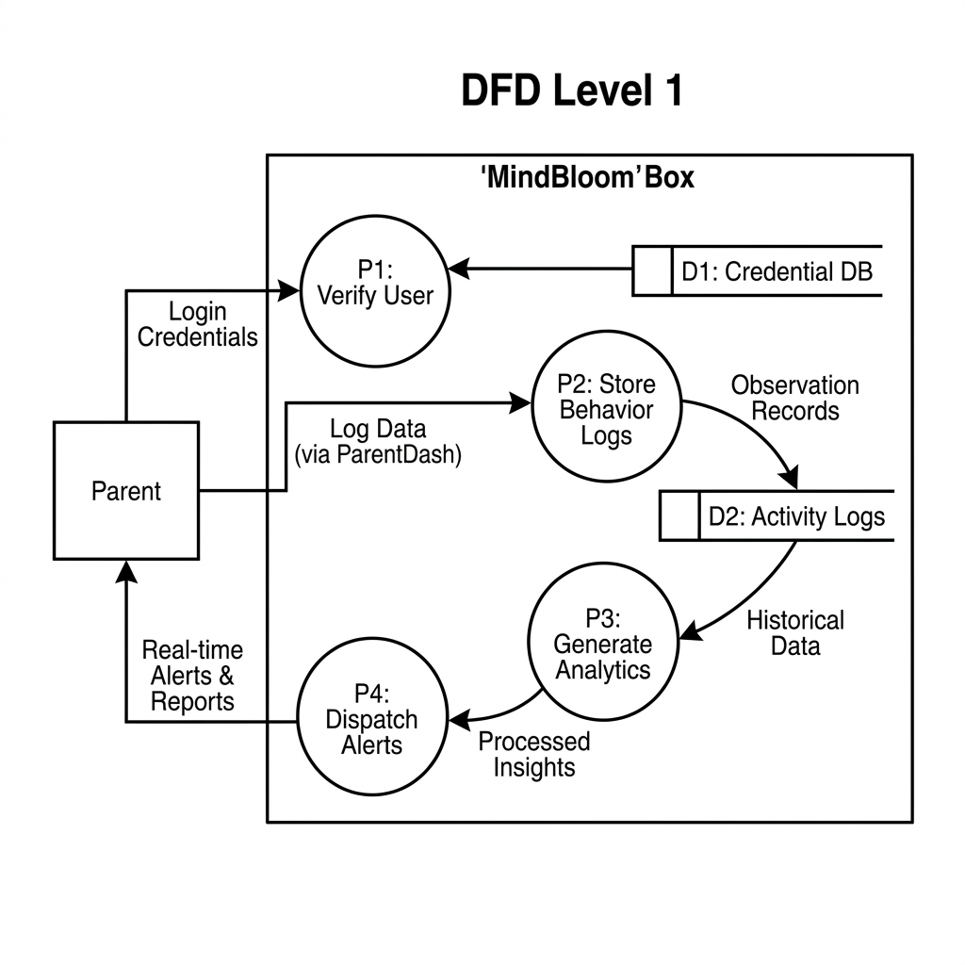

Figure 6.1: Data Flow Diagram

23

6.2 Data Flow Chart:
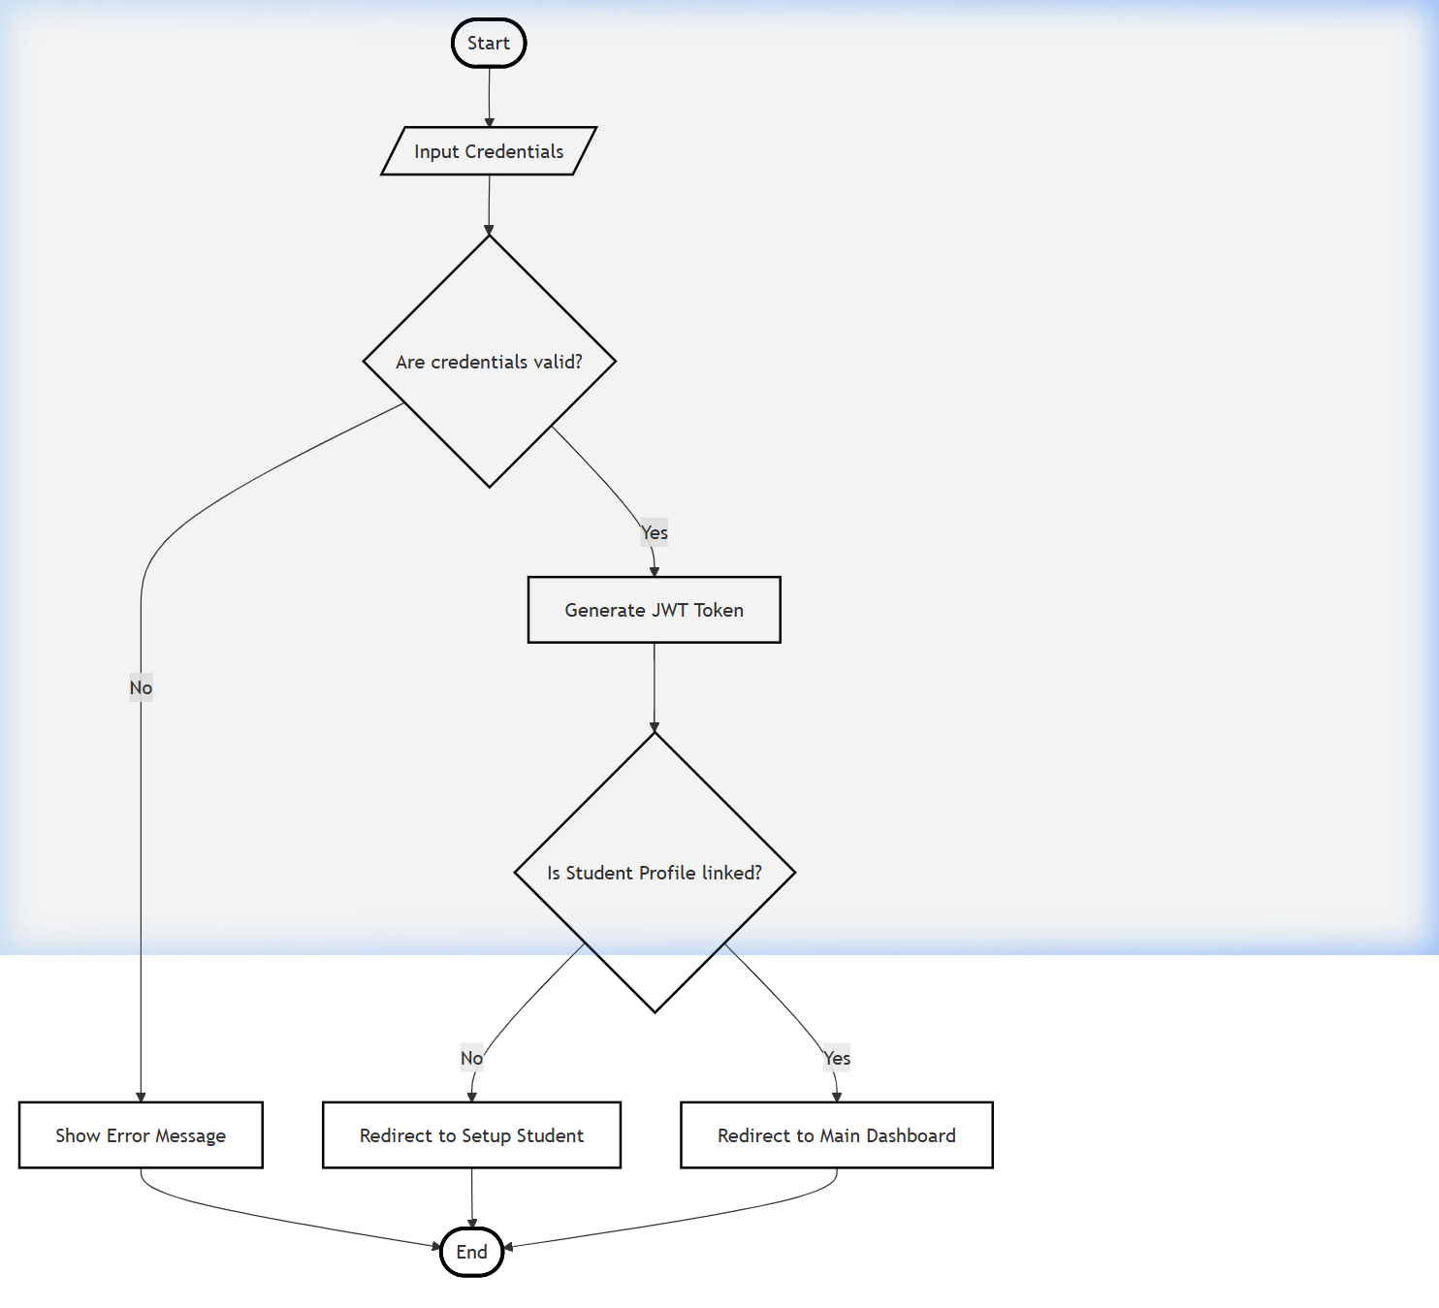

Figure 6.2: Flow Chart

24

Chapter 7
Implemented System

25
7.1 System Architecture:

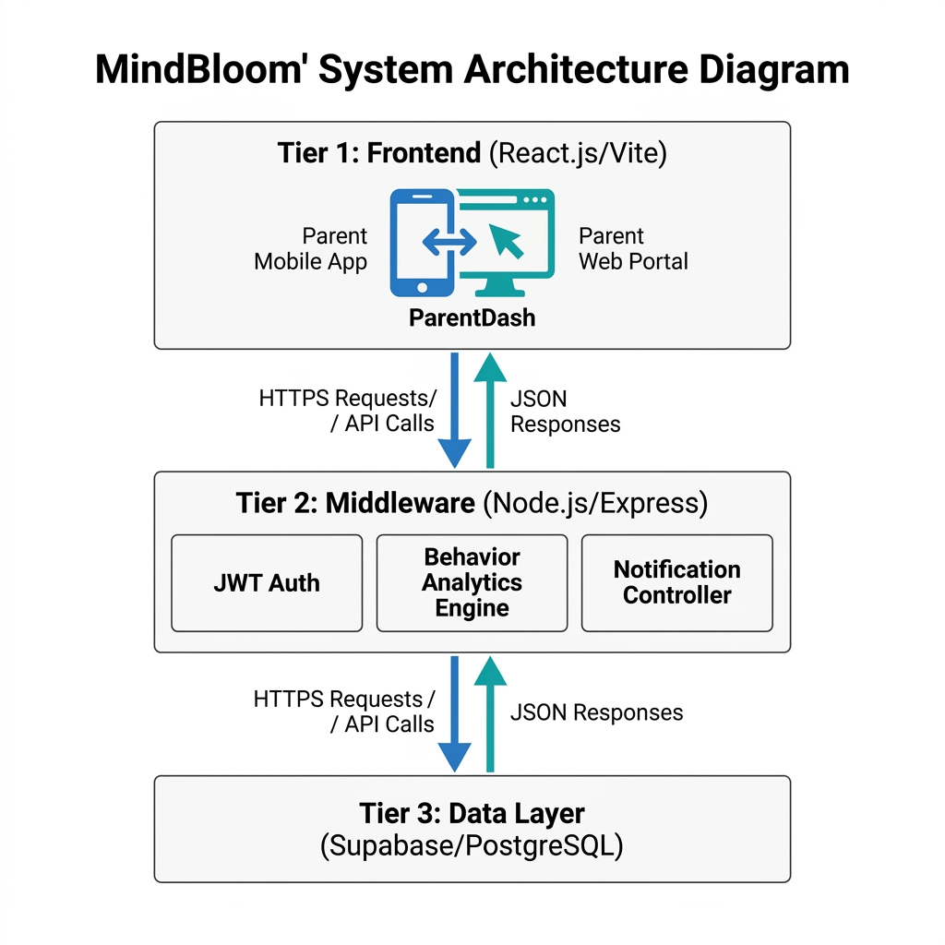

Fig 7.1 System Architecture Diagram

26
7.2 Sample Code:

// Route to post a behavioral observation
app.post('/api/observations', async (req, res) => {
const { studentId, behaviorTag, note, parentId } = req.body;
const { data, error } = await supabase
.from('observations')
.insert([{ student_id: studentId, tag: behaviorTag, comment: note, created_at: new Date() }]);

if (error) res.status(400).send(error);
else res.status(201).send("Log Successful");
});

27
Quiz Page :

const allQuestions = [
{ label: 'Does the child make eye contact during conversations?', name: 'q1', category: 'Social' },
{ label: 'Does the child respond when called by name?', name: 'q2', category: 'Communication' },
{ label: 'Is the child constantly on the go or unable to sit still?', name: 'q3', category: 'Behavioural', reverse: true },
{ label: 'Does the child show interest in playing with other children?', name: 'q4', category: 'Social' },
{ label: 'Can the child express basic emotions (happy, sad, angry)?', name: 'q5', category: 'Emotional' },
{ label: 'Does the child follow simple instructions (e.g., "pick up the toy")?', name: 'q6', category: 'Cognitive' },
{ label: 'Does the child get upset by sudden changes in routine?', name: 'q7', category: 'Behavioural', reverse: true },
{ label: 'Does the child use gestures like pointing or waving?', name: 'q8', category: 'Communication' },
{ label: 'Can the child identify familiar people (parents, siblings)?', name: 'q9', category: 'Cognitive' },

28
{ label: 'Does the child show empathy when someone is upset?', name: 'q10', category: 'Emotional' },
];

export default function Quiz() {
const { setResult } = useQuiz();
const navigate = useNavigate();

const [step, setStep] = useState(0); // 0 = intro, 1..N = questions, N+1 = result
const [answers, setAnswers] = useState({});
const [localResult, setLocalResult] = useState(null);

const totalQuestions = allQuestions.length;
const currentQ = step >= 1 && step <= totalQuestions ? allQuestions[step - 1] : null;
const progress = step === 0 ? 0 : Math.min(step / totalQuestions, 1);

const handleAnswer = (value) => {
const q = allQuestions[step - 1];
setAnswers(prev => ({ ...prev, [q.name]: value }));
29
if (step < totalQuestions) {
setStep(step + 1);
} else {
// Last question answered — calculate
const updatedAnswers = { ...answers, [q.name]: value };
calculateResult(updatedAnswers);
}
};

const calculateResult = (ans) => {
let score = 0;
allQuestions.forEach((q) => {
const a = ans[q.name];
if (q.reverse) {
score += a === 'yes' ? 1 : 0;
} else {
score += a === 'no' ? 1 : 0;
}
});

30
const percentage = Math.round((score / totalQuestions) * 100);
let res;

if (percentage >= 50) {
res = {
type: 'alert',
text: 'Recommendation: Some areas may need attention. Consider consulting a paediatrician for a formal developmental screening.',
score: percentage,
};
} else if (percentage >= 20) {
res = {
type: 'moderate',
text: 'Result: A few areas could use support. Keep monitoring and encourage development through play and interaction.',
score: percentage,
};
} else {
res = {
type: 'fine',
31
text: 'Result: Development appears to be on track! Keep nurturing and monitoring your child\'s growth.',
score: percentage,
};
}

setLocalResult(res);
setResult(res);
setStep(totalQuestions + 1);
};

const handleRetake = () => {
setAnswers({});
setLocalResult(null);
setStep(0);
};

const getCategoryIcon = (cat) => {
const icons = { Social: '🤝', Communication: '💬', Behavioural: '🧩', Emotional: '❤️', Cognitive: '🧠' };
32
return icons[cat] || '📋';
};

return (
<div className={`${styles.quizPage}> animated-bg`}>
<Link to="/" className={styles.homeBtn}>← Back to Home</Link>
{/* Progress Bar */}
<div className={styles.progressBarContainer}>
<div className={styles.progressBar} style={{ width: ${progress * 100}% }}></div>
</div>

<div className={styles.quizCard}>
{/* Step 0: Intro */}
{step === 0 && (
<div className={styles.introStep}>
<div className={styles.introIcon}>🌸</div>
<h2>Quick Milestone Check</h2>
<p>This short quiz helps you understand your child's emotional and social development.</p>
33
<ul className={styles.infoList}>
<li><span>📝</span> {totalQuestions} simple Yes/No questions</li>
<li><span>⏱️</span> Takes about 2 minutes</li>
<li><span>🔒</span> Your answers stay private</li>
<li><span>📊</span> Get instant guidance</li>
</ul>
<button onClick={() => setStep(1)} className={styles.startBtn}>Begin Assessment</button>
</div>
)}

{/* Steps 1..N: Questions */}
{currentQ && (
<div className={styles.questionStep}>
<div className={styles.questionMeta}>
<span className={styles.categoryBadge}>
{getCategoryIcon(currentQ.category)} {currentQ.category}
</span>

34
<span className={styles.counter}>
Question {step} of {totalQuestions}
</span>
</div>
<h2 className={styles.questionText}>{currentQ.label}</h2>
<div className={styles.answerBtns}>
<button
className={${styles.answerBtn} ${styles.yesBtn}}
onClick={() => handleAnswer('yes')}
>
👍 Yes
</button>
<button
className={${styles.answerBtn} ${styles.noBtn}}
onClick={() => handleAnswer('no')}
>
👎 No
</button>
</div>

35
{step > 1 && (
<button className={styles.backBtn} onClick={() => setStep(step - 1)}>
← Previous Question
</button>
)}
</div>
)}

{/* Final: Result */}
{localResult && step > totalQuestions && (
<div className={styles.resultStep}>
<div className={styles.scoreCircle}>
<svg viewBox="0 0 120 120" className={styles.scoreSvg}>
<circle cx="60" cy="60" r="52" className={styles.scoreTrack} />
<circle
cx="60" cy="60" r="52"
className={`${styles.scoreFill} ${
localResult.type === 'alert' ? styles.fillAlert :
36
localResult.type === 'moderate' ? styles.fillModerate : styles.fillFine
}`}
strokeDasharray={${localResult.score * 3.27} 327}
/>
</svg>
<span className={styles.scoreValue}>{localResult.score}%</span>
</div>

<div className={`${styles.resultBox} ${
localResult.type === 'alert' ? styles.alert :
localResult.type === 'moderate' ? styles.moderate : styles.fine
}`}>
<p>{localResult.text}</p>
</div>

<div className={styles.resultActions}>
<button onClick={handleRetake} className={styles.retakeBtn}>🔄 Retake Quiz</button>

37
<button onClick={() => navigate('/dashboard')} className={styles.dashBtn}>📊 View Dashboard</button>
</div>
</div>
)}
</div>
</div>
);
}

38
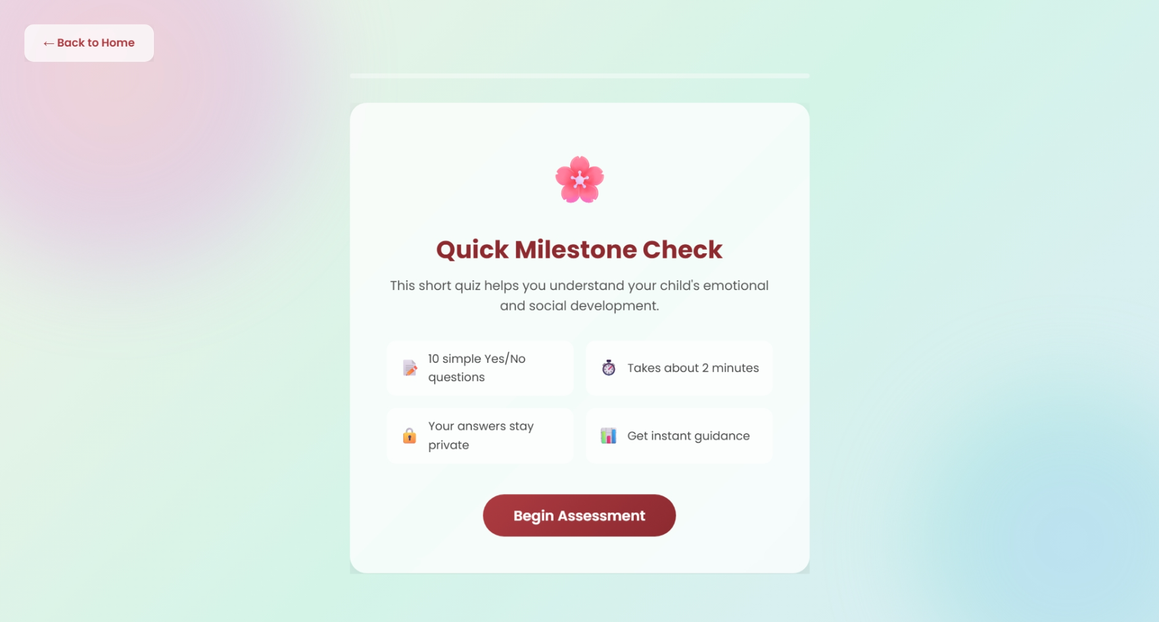
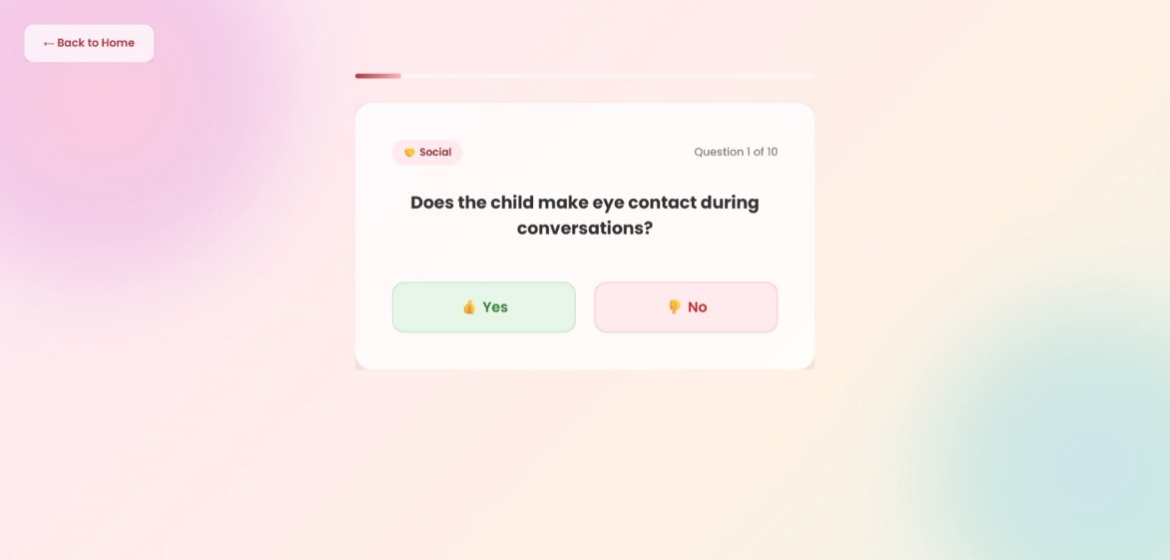
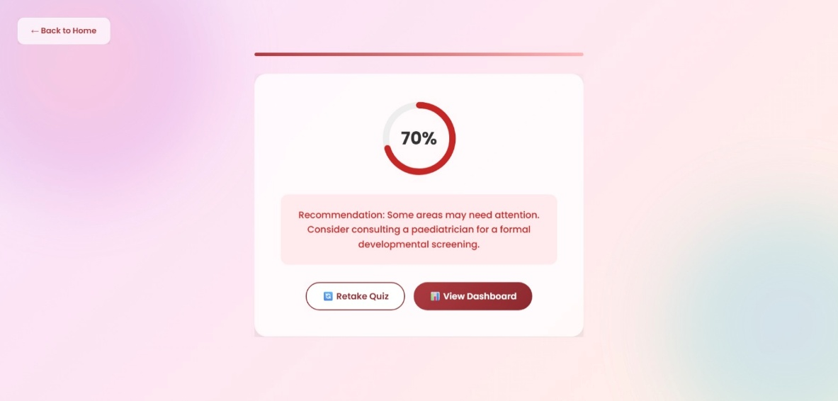

39
Profile Page :

export default function Profile() {
const { user } = useAuth();
const { result } = useQuiz();
const navigate = useNavigate();

const [formData, setFormData] = useState({
name: '',
age: '',
gender: 'Prefer not to say',
parent: user?.name || '',
phone: '',
email: user?.email || '',
concerns: '',
medical: '',
avatar: null
});
const [toast, setToast] = useState('');
const [errors, setErrors] = useState({});

useEffect(() => {
const saved = JSON.parse(localStorage.getItem('mbChildProfile')) || {};
setFormData(prev => ({ ...prev, ...saved }));
}, []);

40
const handleUpload = (e) => {
const file = e.target.files[0];
if (!file || !file.type.startsWith('image/')) return;
const reader = new FileReader();
reader.onload = () => setFormData(prev => ({...prev, avatar: reader.result}));
reader.readAsDataURL(file);
};

const validate = () => {
const newErrors = {};
if (!formData.name.trim()) newErrors.name = 'Child Name is required';
if (!formData.age) newErrors.age = 'Age is required';
if (!formData.parent.trim()) newErrors.parent = 'Parent Name is required';
setErrors(newErrors);
return Object.keys(newErrors).length === 0;
};

const handleSave = () => {
if (validate()) {
localStorage.setItem('mbChildProfile', JSON.stringify(formData));
setToast('Profile Saved ✅');
setTimeout(() => setToast(''), 3000);
}
};

41
const avatarDisplay = formData.avatar
? <img src={formData.avatar} alt="Child Avatar" className={styles.avatarImg} />
: <div className={styles.avatarInitial}>{formData.name ? formData.name[0].toUpperCase() : '?'}</div>;

return (
<div className={`${styles.profileContainer} animated-bg`}>
<div className={styles.profileCard}>
<div className={styles.avatarWrapper}>
{avatarDisplay}
<label htmlFor="avatar-upload" className={styles.uploadBtn} aria-label="Upload photo">
📷
</label>
<input
id="avatar-upload"
type="file"
accept="image/*"
onChange={handleUpload}
className={styles.hiddenInput}
/>
</div>

<h2 className={styles.sectionTitle}>Child Information</h2>
<div className={styles.formGrid}>

42
<div className={styles.inputGroup}>
<label htmlFor="childName">Child Name *</label>
<input
id="childName"
type="text"
value={formData.name}
onChange={e => setFormData({...formData, name: e.target.value})}
className={errors.name ? styles.errorInput : ''}
/>
{errors.name && <span className={styles.errorText}>{errors.name}</span>}
</div>

<div className={styles.inputGroup}>
<label htmlFor="childAge">Age *</label>
<input
id="childAge"
type="number"
min="0" max="18"
value={formData.age}
onChange={e => setFormData({...formData, age: e.target.value})}
className={errors.age ? styles.errorInput : ''}
/>
{errors.age && <span className={styles.errorText}>{errors.age}</span>}
</div>

43
<div className={styles.inputGroup}>
<label htmlFor="childGender">Gender</label>
<select
id="childGender"
value={formData.gender}
onChange={e => setFormData({...formData, gender: e.target.value})}
>
<option>Male</option>
<option>Female</option>
<option>Prefer not to say</option>
</select>
</div>
</div>

<h2 className={styles.sectionTitle}>Parent / Guardian Information</h2>
<div className={styles.formGrid}>
<div className={styles.inputGroup}>
<label htmlFor="parentName">Parent Name *</label>
<input
id="parentName"
type="text"
value={formData.parent}
onChange={e => setFormData({...formData, parent: e.target.value})}
className={errors.parent ? styles.errorInput : ''}
/>

44
{errors.parent && <span className={styles.errorText}>{errors.parent}</span>}
</div>

<div className={styles.inputGroup}>
<label htmlFor="parentPhone">Contact Number</label>
<input
id="parentPhone"
type="tel"
value={formData.phone}
onChange={e => setFormData({...formData, phone: e.target.value})}
/>
</div>

<div className={styles.inputGroup}>
<label htmlFor="parentEmail">Email Address</label>
<input
id="parentEmail"
type="email"
value={formData.email}
onChange={e => setFormData({...formData, email: e.target.value})}
/>
</div>
</div>

<h2 className={styles.sectionTitle}>Additional Details</h2>
45
<div className={styles.inputGroupFull}>
<label htmlFor="concerns">Behavioral Concerns (Optional)</label>
<textarea
id="concerns"
rows="3"
placeholder="e.g. Difficulty focusing, trouble making friends..."
value={formData.concerns}
onChange={e => setFormData({...formData, concerns: e.target.value})}
></textarea>
</div>

<div className={styles.inputGroupFull}>
<label htmlFor="medical">Medical History (Optional)</label>
<textarea
id="medical"
rows="3"
value={formData.medical}
onChange={e => setFormData({...formData, medical: e.target.value})}
></textarea>
</div>

{result && (
<div className={styles.resultCard}>
<h2 className={styles.sectionTitle}>Latest Assessment</h2>
<div className={`${styles.alertBox} ${result.type === 'alert' ? styles.resultAlert : styles.resultFine}`}>
46
{result.text}
</div>
</div>
)}

<div className={styles.actions}>
<button onClick={handleSave} className={styles.saveBtn}>Save Profile</button>
{toast && <div className={styles.toast}>{toast}</div>}
</div>
</div>
</div>
);
}

47
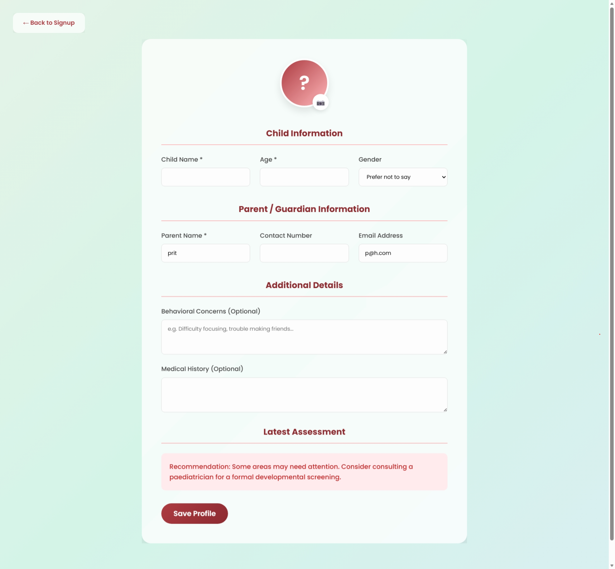

48

Chapter 8
Result Analysis

49

Result Analysis

The result analysis of the MindBloom system focuses on evaluating its performance, accuracy, usability, and effectiveness in achieving the intended objectives of behavioral tracking and early psychological insight generation. The evaluation is based on system testing, simulated user interactions, and analysis of generated behavioral reports.

8.1 Performance Evaluation
The performance of the system was tested under various conditions to ensure smooth functionality and responsiveness.

a) Response Time
The backend APIs developed using Node.js and Express demonstrate fast response times due to their non-blocking architecture. Most user requests, such as logging observations and fetching reports, are processed within 1–2 seconds, ensuring a seamless user experience.

b) Load Time
The frontend interface built using React.js is optimized for performance. The application achieves a load time of approximately less than 1.5 seconds, as measured using performance tools like Lighthouse.

c) Scalability
The use of Supabase (PostgreSQL) ensures that the system can handle multiple concurrent users efficiently. The database design supports scalability, allowing the system to expand for larger datasets and more users without significant performance degradation.

d) Reliability
The system was tested for error handling and data consistency. Proper validation mechanisms and error responses ensure that invalid inputs do not affect system stability.

50
8.2 Functional Testing
The system was tested against all functional requirements to verify correct operation.

Module | Expected Output | Result
User Authentication | Secure login/signup | Successful
Add Observation | Data stored in database | Successful
View Reports | Behavioral insights displayed | Successful
Alerts System | Notification on abnormal patterns | Successful

All modules performed as expected without major issues.

8.3 Accuracy of Behavioral Insights
One of the key features of MindBloom is its ability to generate meaningful insights from behavioral data.

a) Pattern Detection
The system successfully identifies repeated behavioral patterns such as:
- Frequent anger or irritability
- Social withdrawal
- Lack of attention

These patterns are detected based on frequency and consistency of logged observations.

b) AI-Based Suggestions
Based on detected patterns, the system provides suggestions such as:
- Encouraging social interaction
- Providing emotional support
- Monitoring specific behaviors over time

While the current implementation uses rule-based logic, it demonstrates the potential for integration with advanced machine learning models.

51
c) Consistency of Results
Repeated testing with similar data inputs produced consistent outputs, indicating reliability in the system’s analytical logic.

8.4 Overall Evaluation
The MindBloom system successfully meets its primary objectives:
- Provides a structured platform for behavioral tracking
- Enables early detection of potential issues
- Offers analytical insights for decision-making

The system demonstrates strong performance, reliability, and usability, making it a practical and scalable solution for child psychological monitoring.

8.5 Summary
In conclusion, the results indicate that MindBloom is an effective tool for:
- Monitoring child behavior
- Generating meaningful insights
- Supporting early intervention

The system lays a strong foundation for future advancements using artificial intelligence and predictive analytics.

52

Chapter 9
Conclusion and Future scope

53
Conclusion:

The MindBloom project presents a comprehensive and innovative solution to the challenges associated with monitoring and supporting child psychological and behavioral development. In an era where early detection of emotional and developmental issues is critical, the system successfully demonstrates how technology can be leveraged to create a structured, reliable, and collaborative platform for caregivers.
The primary objective of the project was to design and develop a system that enables continuous behavioral tracking, facilitates communication between parents and teachers, and provides meaningful insights for early intervention. Through the implementation of a web-based application using modern technologies such as React.js, Node.js, and Supabase, the system achieves these objectives effectively.
One of the key strengths of MindBloom lies in its ability to centralize behavioral data. By allowing users to log observations in a structured manner, the system ensures that important behavioral patterns are recorded consistently over time. This eliminates the limitations of traditional methods, which rely on memory and subjective interpretation, and instead promotes a data-driven approach to understanding child behavior.
Another significant achievement of the system is its analytical capability. By processing recorded observations, the platform identifies recurring patterns and generates insights that help in recognizing early warning signs of potential psychological issues. This feature is particularly valuable as it supports proactive intervention,
54
rather than reactive measures, thereby improving long-term developmental outcomes.
The project also successfully addresses the issue of communication gaps between parents and teachers. By providing a shared platform, MindBloom ensures that both stakeholders have access to the same information, leading to better coordination and informed decision-making. This collaborative approach enhances the overall effectiveness of behavioral monitoring.
From a technical perspective, the system demonstrates strong performance, scalability, and usability. The use of a modern technology stack ensures efficient handling of user requests, secure data storage, and a responsive user interface. Additionally, the system is designed with a parent-first interaction model, minimizing screen exposure for children and aligning with ethical and pediatric recommendations.
However, it is important to acknowledge that the current system serves as a functional prototype. While it successfully implements core features such as behavioral logging, data analysis, and basic AI-assisted suggestions, there is significant scope for further enhancement.
In conclusion, MindBloom represents a meaningful integration of psychology and technology. It provides a scalable, user-friendly, and effective solution for improving child behavioral monitoring and early intervention. The project not only addresses a real-world problem but also lays a strong foundation for future innovations in the field of digital child development systems.
55
Future Scope:
Although the current implementation of MindBloom achieves its primary objectives, there are several opportunities to enhance its functionality and expand its real-world applicability. The future scope of the project includes both technical advancements and feature enhancements.

1. Advanced Artificial Intelligence Integration
The current system uses rule-based logic for generating suggestions. In the future, it can be enhanced with machine learning and deep learning models to:
- Predict behavioral trends
- Detect complex psychological patterns
- Provide personalized recommendations

2. Predictive Analytics
By analyzing historical data, the system can be upgraded to:
- Forecast potential behavioral issues
- Identify risk factors early
- Suggest preventive measures

56
3. Emotion Recognition Systems
Integration of advanced technologies such as:
- Facial expression analysis
- Voice sentiment analysis
can enable real-time detection of emotions, improving the accuracy of behavioral insights.

4. Wearable Device Integration
The system can be extended to integrate with wearable devices to collect real-time physiological data such as:
- Heart rate
- Sleep patterns
- Activity levels
This would provide a more holistic view of the child’s well-being.

5. Mobile Application Development
Developing a mobile application version of MindBloom would:
- Increase accessibility
- Enable real-time notifications
- Improve user engagement
57
6. Integration with School ERP Systems
MindBloom can be integrated with existing school management systems to:
- Automate data sharing
- Track academic and behavioral performance together
- Improve institutional adoption

7. Multilingual Support
Adding support for multiple languages will:
- Increase usability across diverse regions
- Make the system more inclusive

8. Role Expansion (Psychologists & Experts)
Future versions can include:
- Child psychologists
- Counselors
who can access data and provide professional guidance.

58
9. Offline Functionality
To support rural or low-connectivity areas, the system can be enhanced with:
- Offline data entry
- Sync functionality when internet is available

10. Gamification and Engagement Tools
To improve user engagement:
- Reward-based tracking
- Visual progress indicators
- Interactive dashboards
can be introduced.

The future enhancements of MindBloom have the potential to transform it from a behavioral tracking system into a comprehensive child development ecosystem. With continuous improvements and integration of advanced technologies, the system can play a significant role in improving early childhood care, education, and psychological well-being on a larger scale.

59
References

- WHO – Adolescent Mental Health Report 2022

- UNICEF – State of the World’s Children 2021

- American Psychological Association – Child Development Guidelines

- Piaget, J. – Theories of Cognitive Development

- Vygotsky, L.S. – Mind in Society

60

Acknowledgement

I would like to express my sincere gratitude to my project supervisor,
Mr. S. Vijayakumar, for their invaluable guidance, encouragement, and constructive feedback throughout the development of this project. Their insights were instrumental in shaping MindBloom into a meaningful solution.

I am deeply thankful to the faculty and staff of the Department of
Computer Science Engineering for providing the necessary resources and
a supportive environment to carry out this work. I also extend my appreciation to my peers for their helpful discussions and collaboration during the design and implementation phases.

Special thanks are due to the parents and teachers whose experiences and perspectives inspired the vision behind MindBloom. Their role in nurturing children’s psychological well-being motivated me to create a tool that bridges
the gap between observation and structured guidance.

This project stands as a collective effort, and I extend my sincere appreciation to all those who contributed directly or indirectly to its completion.

Jha Aditi Ashokkumar (220220411)
Nandini Bharti (220220199)
Purva Nilakh (220220160)

61
Appendix I

List of Publications

Journal:
Details of Research Paper
The following research paper has been authored and submitted based on the developmental work and findings of the MindBloom project.
- Paper Title: MindBloom: A Digital Behavioral-Tracking and Psychological Well-being Monitoring Application for Early Childhood Intervention.
- Authors: Jha Aditi Ashokkumar, Nandini Bharti, and Purva Nilakh.
- Journal Name: International Journal of Creative Research Thoughts (IJCRT).
- Journal Category: Peer-Reviewed, Open Access, Multi-disciplinary Journal.
- Key Focus Areas: Child Psychology, Behavioral Tracking, and AI Guidance Systems.
Abstract of the Publication
MindBloom addresses the gap in early identification of emotional challenges in children by integrating behavior tracking and progress analysis. The paper discusses the implementation of a parent-teacher collaborative framework using a Node.js and Supabase backend to identify early warning signs in developmental cycles.

62
Appendix II

Published paper

Manuscript for Publication
- Project Title: MindBloom: A Digital Behavioral-Tracking and Psychological Well-being Monitoring Application
- Lead Authors: Jha Aditi Ashokkumar, Nandini Bharti, Purva Nilakh
- Submission Status: Prepared for Submission / Communicated
- Date of Publication: April, 2026.

63

Appendix III

Plagiarism report of the paper

- Tool Used: Plagiarism Checker
- Similarity Index: 6%
- Status: Acceptable

The plagiarism analysis indicates that the similarity index is within permissible academic limits. No significant instances of copied or unreferenced content were identified, confirming that the report remains original and adheres to academic integrity standards.

64

